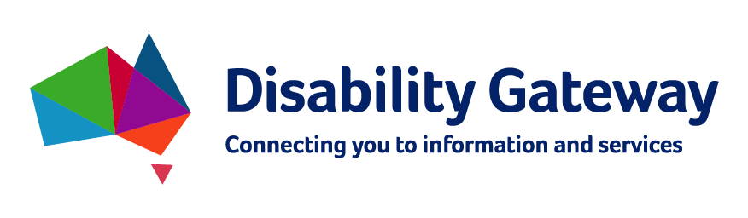

Disability Gateway

Stakeholder kit
Prepared by the Department of Social Services, July 2020.

What’s in the pack?
Introduction 3
Help us spread the message 3
Disability Gateway Details 3
Social Media 4
Social media graphics 6
Key messages 8
Q&As 9

Introduction

The Department of Social Services would like you to know that the new National Disability Information Gateway pilot website is now available at www.disabilitygateway.gov.au.
The pilot website is the first ‘public phase’ of the Australian Government’s commitment to develop a National Disability Information Gateway service (the Disability Gateway).
The Disability Gateway will consist of a website and a national call centre via a dedicated 1800-phone number, to assist people with disability, their families and carers, to find and access information and services.

Help us spread the message

The Department of Social Services would like to encourage you to spread the word about the new Disability Gateway pilot with people with disability, their families and carers that you support.
The Australian Government wants as many people with disability, their families, carers and providers to visit the pilot website and provide feedback on their experience with the service so we can make improvements for the future service.
During the pilot phase there will be continuous feedback, iterations and assessment of the website and it will continue to undergo rigorous testing and quality assurance processes.
In this kit, you will find key messages to help you communicate the benefits of the Disability Gateway and to encourage people to visit the website and provide their feedback.
Together we can ensure all people with disability and their families and carers have access to up-to-date, relevant information linking them to support and services in the community.

Disability Gateway Details

The Disability Gateway pilot website is now available at www.disabilitygateway.gov.au.
People with disability and their families and carers are encouraged to visit the site and provide their feedback to continue to improve the service, prior to the fully operational website.
Following the launch of the pilot website, a fully operational Disability Gateway website and supporting 1800-phone service will launch in January 2021.
This has been created so that people with disability, their families and carers have direct contact access to assistance and other services.
For online services and support, please visit www.disabilitygateway.gov.au.

Social Media

Facebook
The Australian Government wants to hear from you.
Visit the new pilot Disability Gateway website and provide feedback on your experience with the service.
Help us improve the service by visiting www.disabilitygateway.gov.au

The first ‘pilot phase’ of the Australian Government’s new Disability Gateway website is now live. Visit the pilot website now and help us improve the service by
giving your feedback.
Please visit www.disabilitygateway.gov.au and let us know what you think.

Give your feedback!

The Government has created a pilot for the new Disability Gateway website to ensure
people with disability, their families and carers receive the most effective,
accessible and people centred service available.
Please visit www.disabilitygateway.gov.au and let us know what you think.

Are you an accredited disability service provider?
To have your services included on the new Disability Gateway pilot website please contact us through the feedback button located on the right hand side at www.disabilitygateway.gov.au.

Twitter
The first ‘pilot phase’ of the Australian Government’s new Disability Gateway website is now live. Visit the pilot website now and help improve the service by
giving your feedback.
Please visit www.disabilitygateway.gov.au

The Australian Government wants to hear from you.
Visit the new pilot Disability Gateway website and provide feedback on your experience with the service.
Help improve the service by visiting www.disabilitygateway.gov.au

The Australian Government wants your feedback!

A pilot for the new Disability Gateway website is now live. Make sure you visit the site and give your feedback to help improve the service.
Visit www.disabilitygateway.gov.au and let them know what you think.

Social media graphics

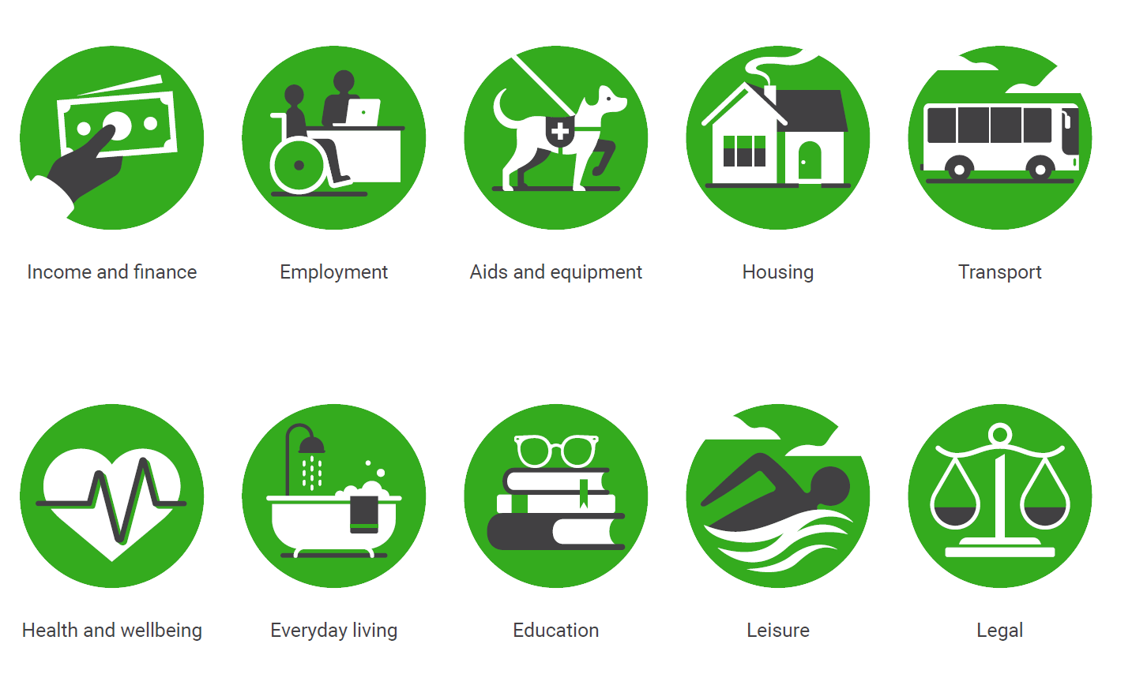
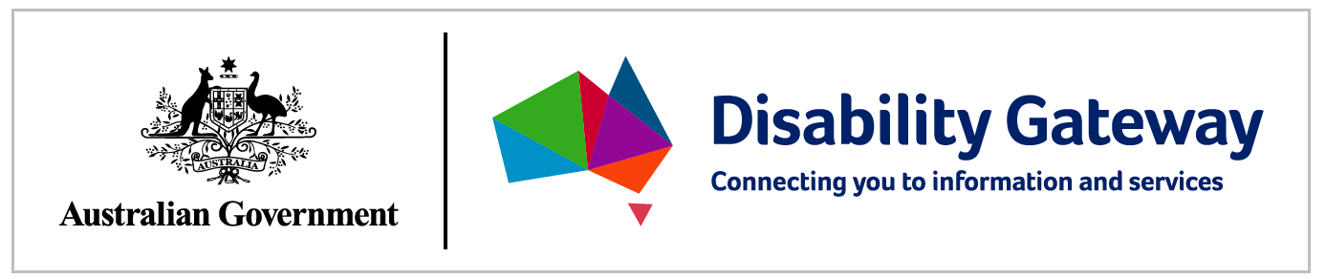
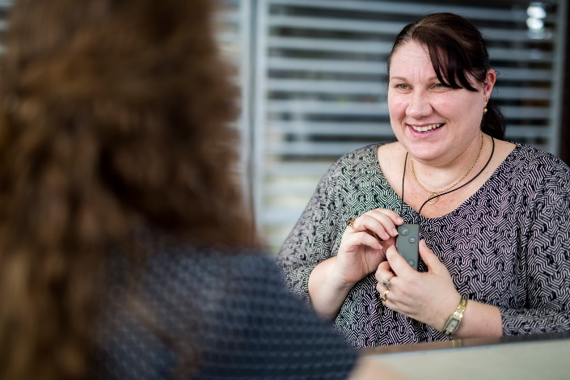
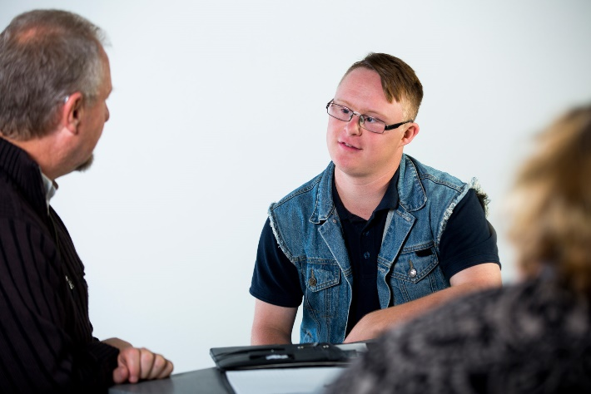 | 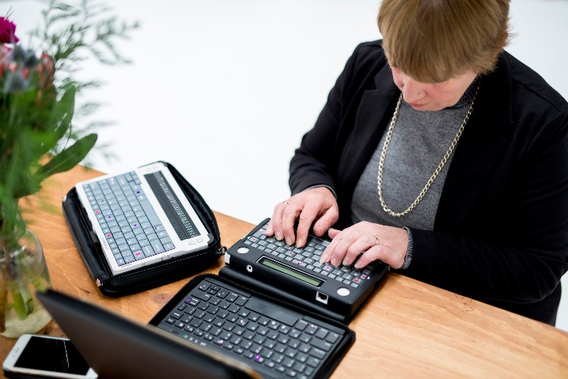
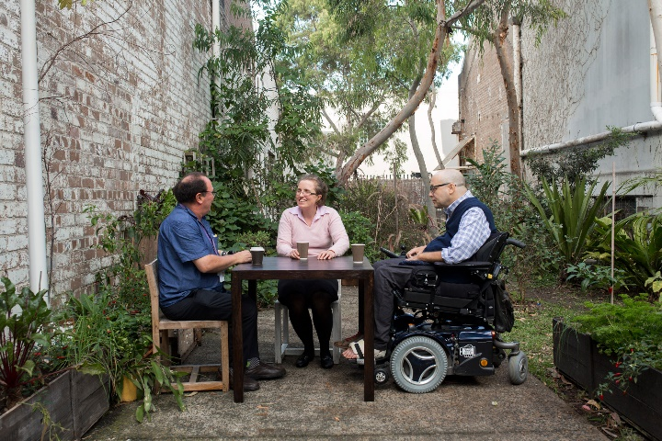 | 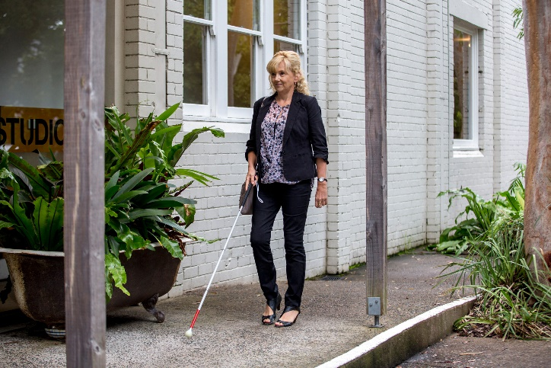

Key messages

- During the 2019 election campaign, Prime Minster Scott Morrison committed to develop the National Disability Information Gateway (the Disability Gateway), to help improve the lives of people with disability, their families and carers.
- The Disability Gateway will include a website and 1800-phone number, to assist all people with disability and their families to locate and access information and services in their communities.
- The first ‘public phase’ of the Disability Gateway is now available at www.disabilitygateway.gov.au until January 2021.
- People with disability and their families and carers are encouraged to visit the pilot website and provide their feedback prior to the fully operational Disability Gateway website and supporting 1800-phone line service launching in January 2021.
- The Department has consulted with people with lived experience of disability, their families and carers and the broader disability sector, and will continue to do so, through the pilot phase of the Disability Gateway, to ensure needs and expectations of people with disability are considered in the design of the Disability Gateway.
- The Government’s aim is to ensure people with disability, their families and carers receive the most effective, accessible and people-centred service available. Q&As
When will the 1800-phone number be available and how can people find the number?
The 1800-phone number will be available from January 2021, and will be located on the Disability Gateway website.
Who is eligible to call the 1800-phone number?
Anyone can call the Disability Gateway. The Disability Gateway service has been created for people with disability, their families and carers to use to have direct access to information and other services.
Why should people with disability or carers use this website?
The Disability Gateway seeks to improve access to information about disability services and supports that is currently fragmented and difficult to navigate. For example, the Disability Gateway will assist people with disability to find a local advocacy service, disability related events and disability service providers.
Who was involved in the consulting process?
The Department of Social Services has and will continue to consult with people with lived experience of disability and the broader disability sector, to ensure their needs and expectations are considered in the design of the Disability Gateway.

How will the Government ensure that the Disability Gateway services are accessible and appropriate?

The Department of Social Services has consulted with people with lived experience of disability and the broader disability sector, to ensure their accessibility needs and expectations were considered in the design of service for the Disability Gateway.
Experts in Web Content Accessibility Guidelines (WCAG) and user experience were engaged during the website design process, to ensure the site is accessible and fit for purpose and to ensure that the website complies with the Digital Transformation Agency guidelines.
As the website enters the pilot phase, which is viewable by everyone, there will be continuous feedback, iterations and assessment of the site. The website and proof of concept support services have undergone rigorous testing and quality assurance processes before launch.
The Government is determined to take the time to get it right.

